[](https://www.iiuc.ac.bd/)

**MID Project**

**Project Name: Electricity Billing System**

**Submission date- 12 October , 2021**

**Course Title- Software Development 1**

**Course Code: CSE-2340**

Submited to-

**Mr. Mohammad Mahadi Hassan**

***Assistant Professor, CSE, IIUC***

***Cell: 01957719040*, mahadi.cse@yahoo.com**

Submitted by-

**MD. SOROWAR MAHABUB RABBY**

Matric ID: ***C201032*,** Section: ***3AM* ,** Semester**: *3rd***

**Department of CSE (***Computer Science and Engineering***), IIUC**

**Cell:** *01834756433, 01521564157,* [*c201032@ugrad.iiuc.ac.bd*](mailto:c201032@ugrad.iiuc.ac.bd)

**Electricity Billing System** is a software-based application developed in Java programming language. The project aims at serving the department of electricity by computerizing the billing system. It mainly focuses on the calculation of Units consumed during the specified time and the money to be paid to electricity offices. This computerized system will make the overall billing system easy, accessible, comfortable and effective for consumers.

Here, I have briefly described this project with its features and by comparing it to the conventional system of electricity billing.

Electricity Billing System Project Abstract:

**Features:**

1. To make the billing system more service-oriented and simple, the following features have been implemented in the project.
2. The application has high speed of performance with accuracy and efficiency.
3. The software provides facility of data sharing.
4. It doesn’t require any staffs as in the conventional system. Once it is installed on the system, only the meter readings are to be given by the customer.
5. The software provides facility of data printing.
6. The electricity billing software calculates the units consumed by the customer and makes bills.
7. It requires small storage for installation and functioning.
8. There is provision for debugging if any problem is encountered in the system.

**Existing and Proposed System:**

The conventional system of electricity billing is not so effective; one staff has to visit each customer’s house to note the meter readings and collect the data. Then, another staff has to compute the consumed units and calculate the money to be paid. Again, the bills prepared are to be delivered to customers. Finally, individual customer has to go to electricity office to pay their dues.

Hence, the conventional electricity billing system is uneconomical, requires many staffs to do simple jobs and is a lengthy process overall. In order to solve this lengthy process of billing, a web based computerized system is essential. This proposed electricity billing system project overcomes all these drawbacks with the features aforementioned. It is beneficial to both consumers and the company which provides electricity.

With the new system, there is reduction in the number of staffs to be employed by the company. The working speed and performance of the software is faster with high performance which saves time. Furthermore, there is very little chance of miscalculation and being corrupted by the staffs.

**The calculation System:**

|  |  |  |
| --- | --- | --- |
| **Charge per Unit** | | |
| **Unit Range** | **Amount (Taka)** | **Remarks** |
| <75 | 3.50 | \**if* ***Total Amount is less than 125 Taka*** *then minimum* ***Total Amount will be 125 Taka*** *as meter charge!* |
| <120 | 7.00 |
| <300 | 10.00 |
| <1000 | 18.50 |
| >=1000 | 25.00 |

**Screenshots:**

**1**

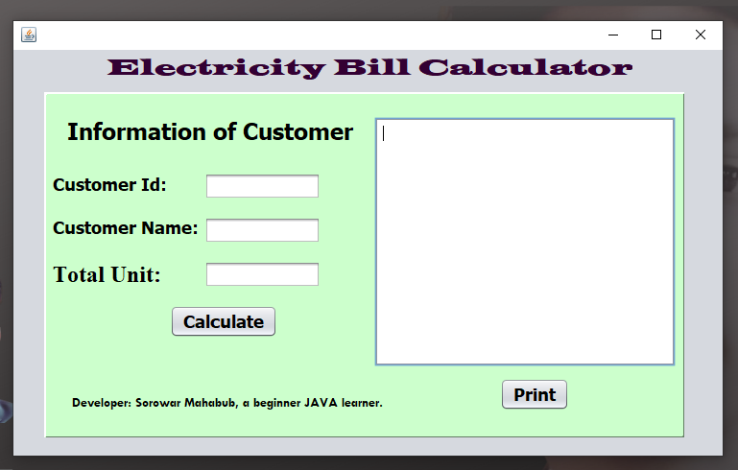

**2**

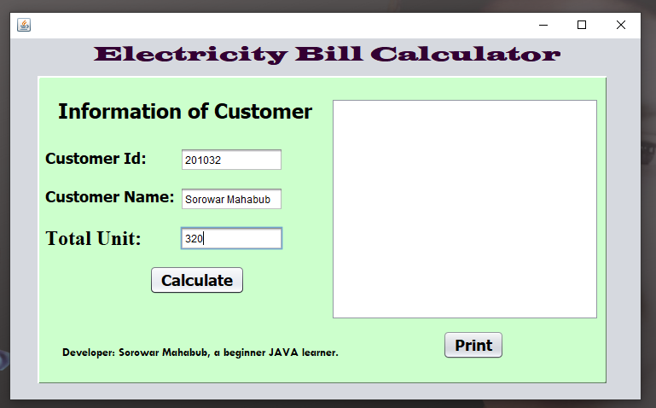

**3**

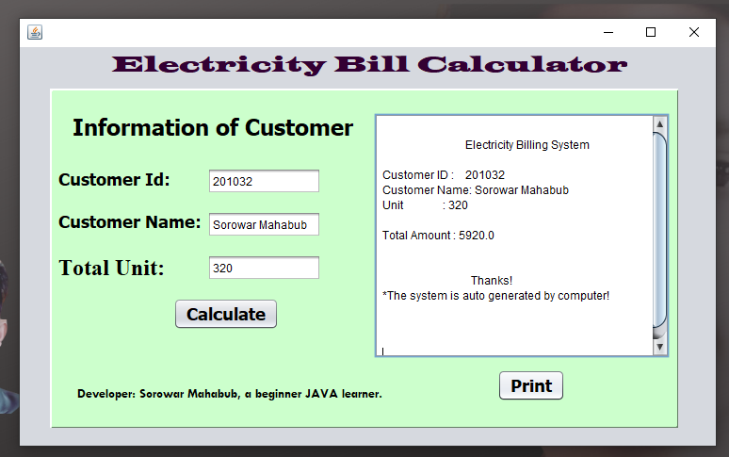

**4**

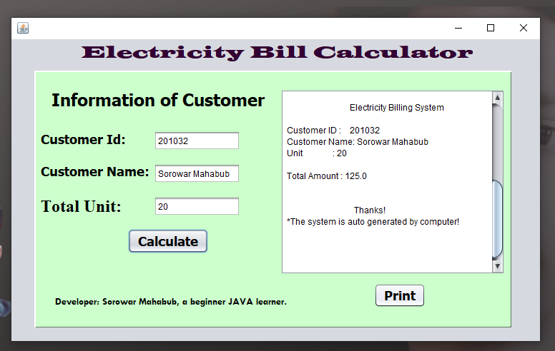

**5**

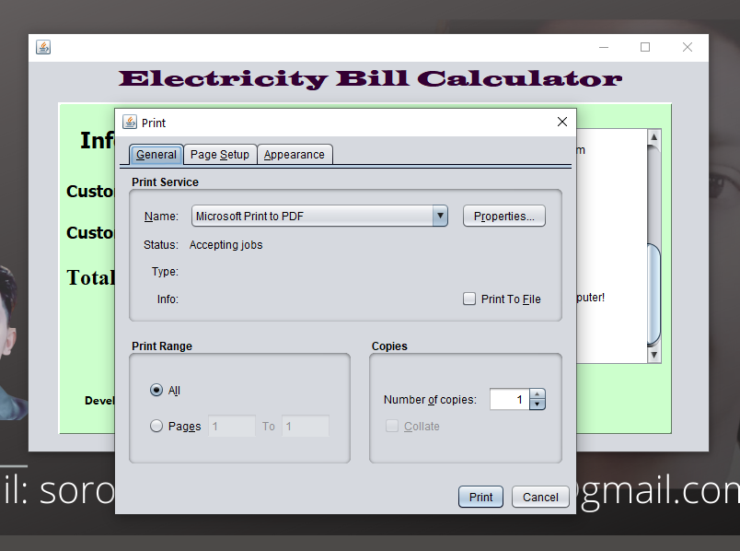

**6**

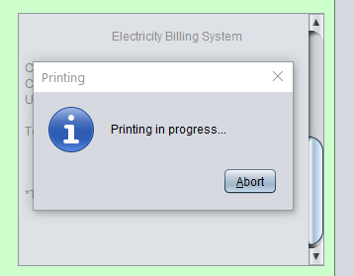

**Conclusion:**

A new software system to modernize the electricity billing procedure is required. This electricity billing system project would replace the existing traditional and analog type of electricity billing system ensuring security, ease and comfort in billing. It meets the current user demands, and new features can be easily integrated into the system in future as per user requirements.

Submitted by-

**MD. SOROWAR MAHABUB RABBY**

Matric ID: **C201032**, Section: 3**AM**

Department of CSE (Computer Science and Engineering)